|  |
| --- |
| **Annual Report**  **2023 - 2024** |

|  |  |  |
| --- | --- | --- |
|  |  |  |

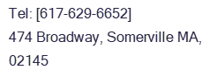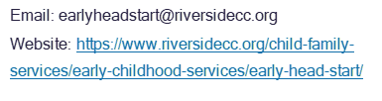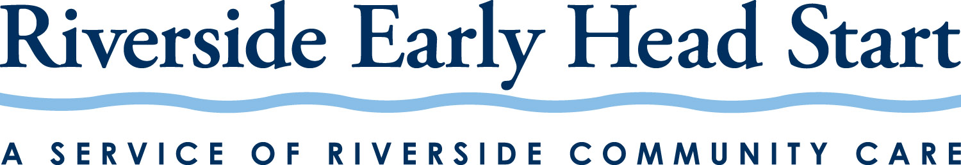

Tel: [617-629-6652]

474 Broadway

Somerville, MA 02145

**Somerville Early Head Start – Van Hardy Community Plot**

Mission StatementS

**Riverside Community Care Mission Statement**

**We make a difference in the lives of individuals, families, and communities through innovative and compassionate behavioral healthcare and human services, and we use technology to improve access to quality care and expand our impact.**

We believe that –

* hope is an essential element of our work.
* quality care should be available to all.
* excellence must be a guiding force in everything we do.
* advocacy on healthcare and human services is our responsibility.
* a diverse and respectful workforce is essential to attaining our mission.

**Riverside Early Head Start Mission Statement**

**Our mission is to promote the health, well-being, social emotional growth, and cognitive development of young children and to support the self-empowerment of families.**

**Riverside Early Head Start** **Program Goals 2022-2027**

The program will *partner with expert organizations* to build sustainable economic and training pathways which strengthen *family well-being*, *economic mobility*, and *financial literacy.*

The program will recruit, retain, and develop qualified staff to serve and promote industry *Trauma Informed Care; Inclusionary; and Diversity* best practices which support *measurable improvements* to children and families *social-emotional, cognitive, and physical well-being.*

The program will continue to *develop, structure, and utilize* strong management systems (and processes) to ensure *measurable, responsive, and individualized* outcomes for children and families.

The program will *partner with community and enrolled* families to foster environments and shared learning experiences which *support developing and employing* child development domain capacity and appropriate school readiness supports within *home and community environments.*

# Director’s Corner

Parents, Community Members, and Partners:

The Riverside Early Head Start program, staff, parents, and community members continue to remain steadfast in their commitment to support each other and provide quality programming.

We continue to secure community partnerships and ongoing training resources, such as the well-received MASSAIMH Endorsement Pathway and Reflective Practice Consultation Series, Financial Literacy Training Series, and Reggio Emilia Environments and Instructional Practice Initiative within the cities of Cambridge, Medford, Somerville, and Greater Boston region. Each partnership continues to assist us in supporting skills, tools, and resource pathways which bolster our program’s collective ability to provide high quality services, targeting the needs of enrolled families and coalition network partners.

We continue to define and refine internal monitoring systems and deliver on our mission to deliver high quality educational in-home activities, effective curriculum planning, and individualized assessment and observations for all enrolled children.

In an effort to support capacity development across all staffing levels we have continued to partner with the Massachusetts Association of Infant and Toddler Mental Health and Brazelton’s Touch Points Center. Agencies of expertise, such as these, continue to assist all staff in developing Reflective Practice, Infant and Toddler Mental Health capacity, and social emotional and wellness resiliency.

We are excited to share that we utilized Office of Head Start carry over funding last year to address several program facility modernization priorities. Funding allocations allowed us to refresh the onsite socialization room to align with Reggio Emilia inspired environments and instructional materials and revise our large conference room training space to support modular, and responsive training environments meeting the needs of program staff, clients, and community members. In addition, this funding allowed us to provide additional training, leadership, advocacy, and consultation services to support building and maintaining staff, client, and program initiatives.

We extend sincere thanks to our devoted community partners, as each continue to support our community and program, reinforcing a collective community strengths-based approach.

It remains our intention to best support our community, within a responsive, warm, and engaged environment; we hope to deliver on this promise and will remain steadfast with the collective trust you all continue to place in our hands.

Thank you,

Emilie Laforest

|  |  |  |  |  |  |  |  |
| --- | --- | --- | --- | --- | --- | --- | --- |
| **FINANCIAL STATEMENTS** | | |  |  |  |  |  |
|  |  |  |  |  |  |  |  |
| **Total amount of public and private funds received (A)** | | | |  |  |  |  |
| Department of Health and Human Services, Administration of Children and Families: Office of Head Start: | | | | | | |  |
|  |  |  |  |  |  |  |  |
| Annual Grant Award: | $1,475,788.00 |  |  |  |  |  |  |
| Carry Over Budget: | $319,946.00 |  |  |  |  |  |  |
| Cost of Living Adjustment: | $42,943.00 |  |  |  |  |  |  |
|  |  |  |  |  |  |  |  |
| Department of Early Education and Care, State Supplemental Grant: Head Start State Collaboration Office: | | | | | | |  |
|  | Annual Grant Award: | $144,810.00 |  |  |  |  |  |
|  |  |  |  |  |  |  |  |
| **Budgetary Projections & Expenditures (B)** | | |  |  |  |  |  |
|  |  |  |  |  |  |  |  |
| **DESCRIPTION** | **Total Budget** | **20% Non-Federal Share** | **Actual Expenditures** |  |  |  |  |
| **Federal** |  |  |  |  |
| **A.     Personnel** | $936,153 | $72,800 | $899,774 |  |  |  |  |
| **B.      Fringe Benefits** | $181,974 | $13,498 | $191,032 |  |  |  |  |
| **C.      Travel: T&TA** | $4,000 | $0 | $0 |  |  |  |  |
| **D.     Equipment** | $0 | $0 | $0 |  |  |  |  |
| **E.      Supplies** | $43,796 | $0 | $193,463 |  |  |  |  |
| **F.       Contractual** | $31,706 | $10,085 | $36,004 |  |  |  |  |
| **G.     Construction** | $0 | $0 | $0 |  |  |  |  |
| **H.     Other** | $473,456 | $235,988 | $270,786 |  |  |  |  |
| **Other T & TA** | $26,931 | $33,951 | $58,913 |  |  |  |  |
| **I.        Total Direct Charges** | $1,698,016 | $366,322 | $1,649,972 |  |  |  |  |
| **J.        Indirect Charges** | $140,661 | $13,361 | $207,452 |  |  |  |  |
| **K.      TOTALS** | $1,838,677 | $379,683 | $1,857,425 |  |  |  |  |
|  |  |  |  |  |  |  |  |
| **Federal Funding** | $1,838,677 |  | $1,857,425 |  |  |  |  |
| **NFS Match** | $379,683 |  | $85,709 |  |  |  |  |
| **Totals** | $2,218,360 |  | $1,943,134 |  |  |  |  |
|  |  |  |  |  |  |  |  |
|  |  |  |  |  |  |  |  |

## Program Cumulative Enrollment (C)

REHS served 64 Children, with nearly 30% of enrolled children being two years and under, along with 4 pregnant women over the 2022-2023 program year. Monthly program enrollment averaged 44-63% throughout the program year, largely because of the workforce and credentialling challenges within our Home Visiting field. We are happy to report that due to extensive outreach efforts in identifying eligible families needing our services, we reached full enrollment of 80 participants as of January 31, 2024. Extensive ongoing efforts are in place to monitor and ensure continued success in this area. A first entry to field Program Support Specialist-HVCDA training position will continue to help the program identify personnel fit for Home Visiting services but without required Office of Head Start credentials. This position will ensure adequate orientation to OHS requirements, program mission, philosophy, and Home Visitor Child Development Associate credentialing within the six-month orientation period.

## Secretary Review and Financial Audit (D)

No formal review from the Secretary occurred during this reporting period.

Financial audit: FY23 results show a small deficit for the year, with formal date of June 30, 2023. Auditors: Audit by CliftonLarsonAllen LLP found no material weakness or significant deficiencies identified throughout the extensive agency audit.

REHS received their most recent Focus Area One Federal Monitoring Review during the week of October 16-18, 2023. The Focus Area One review consisted of a virtual weeklong discussion, data explorations, and interviews with staff, parents, and Board members which audited the overall program design, management, and governance structures. The program was found to be complying without noted deficiency or non-compliance concerns, although three areas of concern were noted. These areas included parent engagement in Health Services Advisory Committee, Expulsion Policy and Suspension Policy. The program is working on these areas of concern.

Program expects to receive an upcoming Focus Area Two Federal Monitoring Review to align with the new five-year project period May 1, 2024- April 30, 2027.

## Medical and Dental Exams for Enrolled Children (E)

REHS children and prenatal families continue to receive appropriate support in accessing and securing medical, dental, immunizations, sensory and developmental services. Approximately 100% have identified medical homes, 44% dental homes, 84% up to date Well-checks, 68% up to date immunizations, and 100% identified as having access to medical insurance.

## 

## Parent Involvement Activities (F)

The Program’s 5-part Financial Literacy Training series was well received with 11 parents attending and completing the 5-part Financial Literacy training series. The series prioritized parental skill building and exposure to core financial services. Training session topics included *Financial Services 101; Asset Building; Fraud Prevention; and Sustainable Fiscal Planning*.

The Program was able to secure a garden plot through Van Hardy Community Garden in Somerville. The garden allowed for education opportunities and for families to grow and/or harvest produce to provide for their families.

The Program’s Year End Transition Event was well attended with 11 children transitioning and a total of 32 family members attending the outdoor celebration. Community partner Somerville Growing Center hosted the outdoor celebration with Seth Hanson providing music and instruments for children to join in.

The Program’s Policy Council members continue to actively engage with program planning and grant funding proposals. With the support and input of all, we submitted, and we were awarded ongoing funding through our 5-Year gran application.

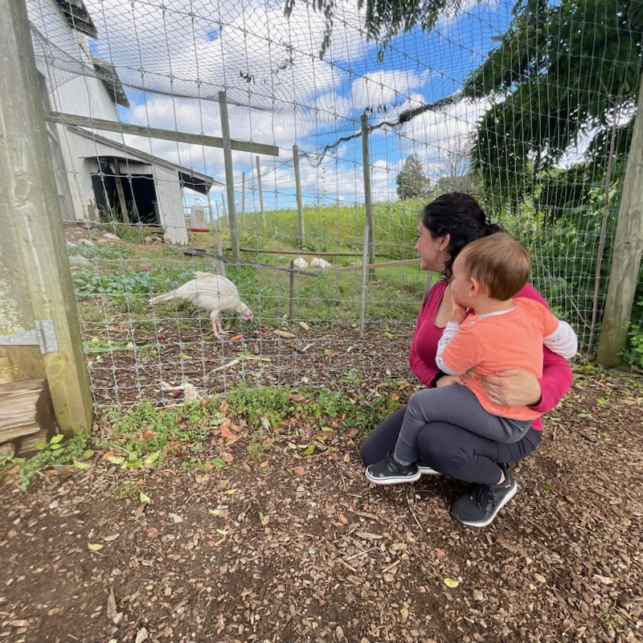

The Program offered two Family Summer Fun events that were well attended with children, family members, friends, and community members attending the outdoor celebrations.

**School Readiness (G)**

Riverside Early Head Start continues to prepare children for preschool and later school experiences through the provision of individualized curriculum that addresses social, emotional, physical, language, and cognitive development, as well as approaches to learning, literacy, and mathematics. Through age-appropriate screenings (ASQ/ASQ-SE), observations and assessment (DRDP), and ongoing family input, each Home Visitor partners with parents to create an individualized school readiness plan that reflects the goals for each child. During the program year 2022-2023 REHS facilitated multiple professional development opportunities for staff centered on school readiness, quality assessment and observations. The program offered a Reggio Emilia Training Cohort to support staff in the approach to integration into services. The program continues to collaboratively partner with parents to ensure the reinforcement of best practices and strategies which promote school readiness. We plan to maintain our approach and goal selection throughout 2023-2024 to ensure progress is maintained. Child outcomes data demonstrated that most two-year-old children met or exceeded expectations in these areas as follows:

|  |  |  |  |  |  |  |  |  |  |  |  |  |  |  |  |  |  |  |
| --- | --- | --- | --- | --- | --- | --- | --- | --- | --- | --- | --- | --- | --- | --- | --- | --- | --- | --- |
| |  |  |  | | --- | --- | --- | | DEVELOPMENTAL  DOMAIN | GOAL | % OF TWO-YEAR-OLDS WHO MET/  EXCEEDED EXPECTATIONS | | SOCIAL-EMOTIONAL | Manage emotions with the help of familiar adults | 75% | | PHYSICAL | Begin to learn and practice healthy and safe habits | 75% | | LANGUAGE | Use increasingly complex and varied language for con-  versations and communication | 75% | | APPROACHES TO LEARNING | Develop strategies to make discoveries and solve problems using creativity, persistence, and  imagination | 75% | | COGNITION | Develop emerging mathematical skills and knowledge | 75% | |

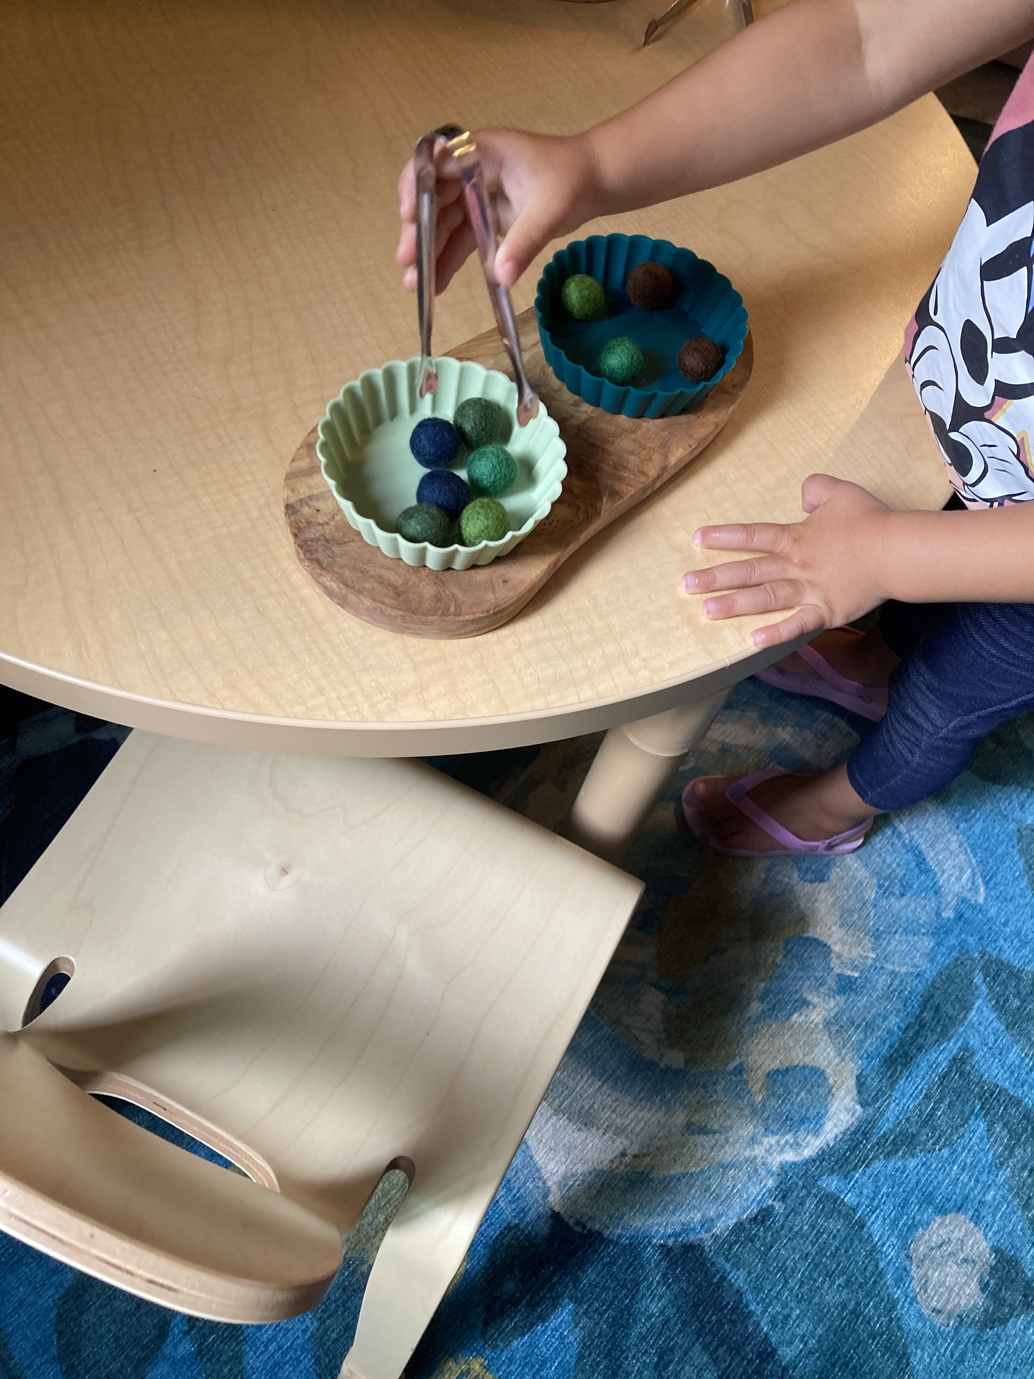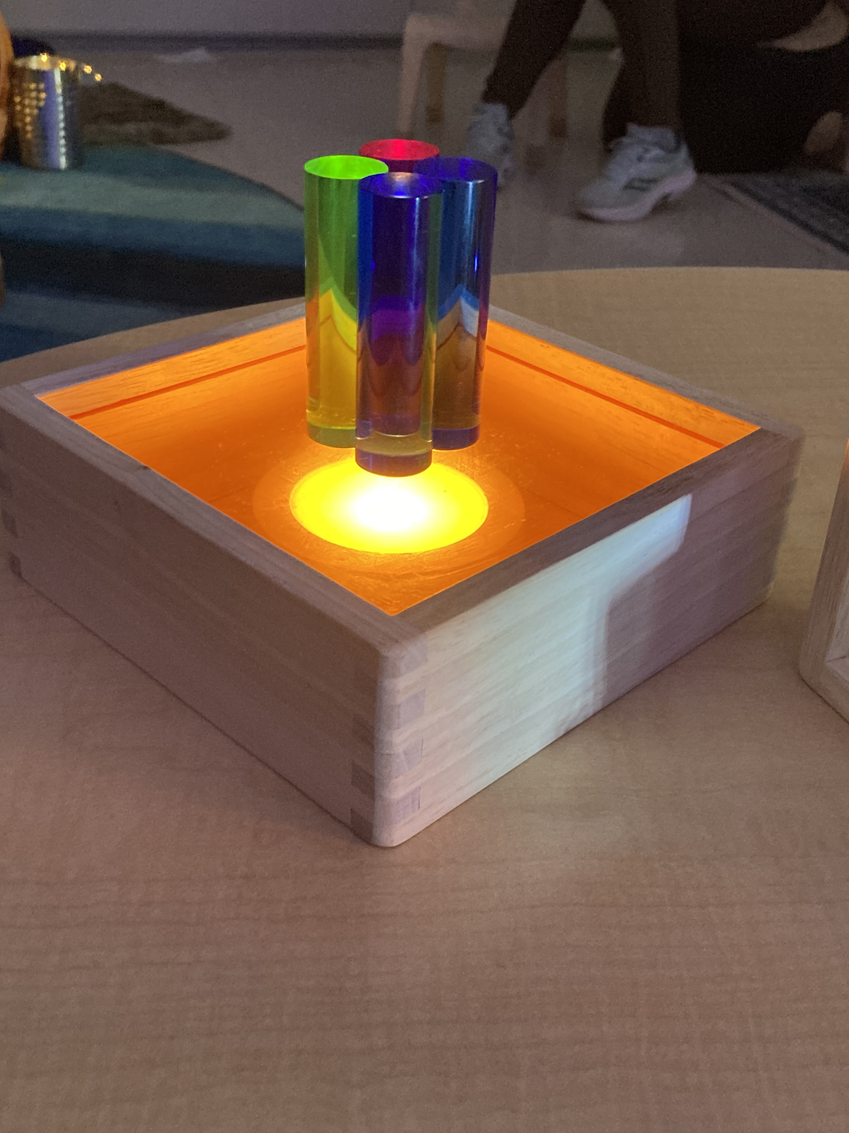

**REHS - MASSAIMH Endorsement**

## MASSAIMH

The Massachusetts Association for Infant Mental Health (MASSAIMH) is a non-profit interdisciplinary, professional statewide organization established to promote and support the optimal development of infants, very young children, and families through relationship-focused workforce development and advocacy efforts.

We recognize the vital importance of the foundational early development years and that families need and deserve the support necessary to nurture their children. Like you, we are providers and professionals serving young children and families and are dedicated to promoting healthy social and emotional development in the earliest stages and relationships of life.

## Mission Statement

To promote family and infant and early childhood social and emotional well-being as foundational to development.

To enhance and link specialized training, research, policy, advocacy, and preventive and therapeutic intervention through collaboration across systems, disciplines, and providers.

# A picture containing text, clipart Description automatically generatedAnnual REPORT: Head Start 2007 Act

Head Start 2007 Act Compliance Statement

This annual report has been prepared in compliance with the Head Start Reauthorization Act of 2007. The Act Section 644 (2) states that: “Each Head Start agency shall make available to the public a report published at least once in each fiscal year that dis closes the following information from the recently concluded fiscal year, except that reporting such information shall not reveal personally identifiable information about an individual child or parent:

1. The total amount of public and private funds received and the amount from each

source.

1. An explanation of budgetary expenditures and proposed budget for the fiscal

year.

1. The total number of children and families served, the average monthly enrollment (as a percentage of funded enrollment), and the percentage of eligible children served.
2. The results of the most recent review by the Secretary and the financial audit.
3. The percentage of enrolled children that received medical and dental exams.
4. Information about parent involvement activities.
5. The agency’s efforts to prepare children for kindergarten.
6. Any other information required by the Secretary.